Name Per

Unit 5 Part 2 Review #3 Worksheet

3-Tri Intermediate Algebra A

**Simplify Solutions:  
1. 2. 3.**

**4. 5. 6.**

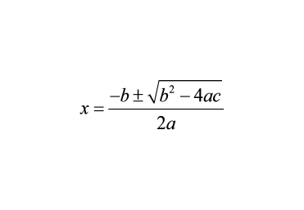

**7. $x^{2}-4x+7=0$**    
a) What is the discriminant? Show work.

b) How many and what type of solutions are there?   
  
c) Solve this equation using **ANY** **method of your choice**.Show work.

**8. $x^{2}+5x=14$**

a) What is the discriminant? Show work.

b) How many and what type of solutions are there?   
  
c) Solve this equation using **ANY** **method of your choice**. Show work.



**9.** The height of an object launched vertically is given by  where h is the height of the object in feet and t is the time in seconds.

1. Find the height of the rocket after 1 second.

**WORK SPACE**

1. At what time(s) is the rocket at a height of 202 ft?
2. When does the rocket reach the maximum height? What is the maximum height?

1. 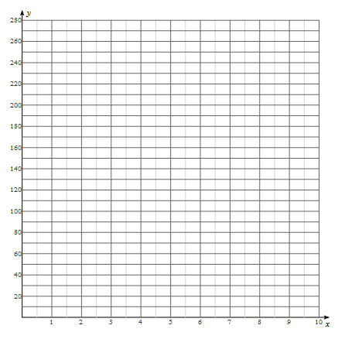When does the rocket land on the ground?
2. Using the information you have collected above, sketch a graph depicting the rockets height at time t.

*height (feet)*

1. The equation you wrote above only models the height of the rocket while it is in the air. Find the domain and range of this function.

*time (seconds)*